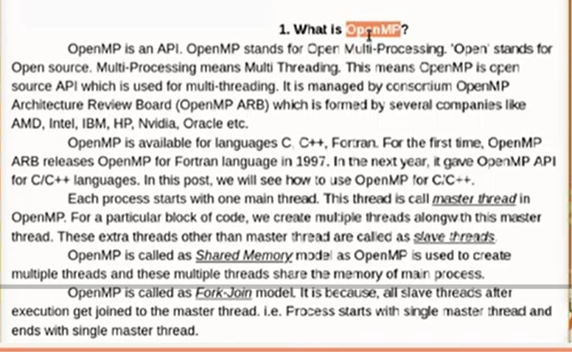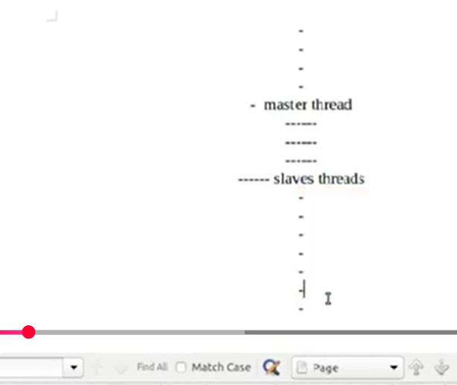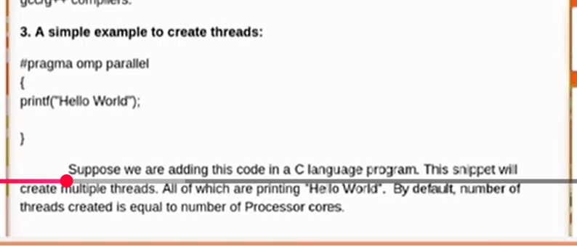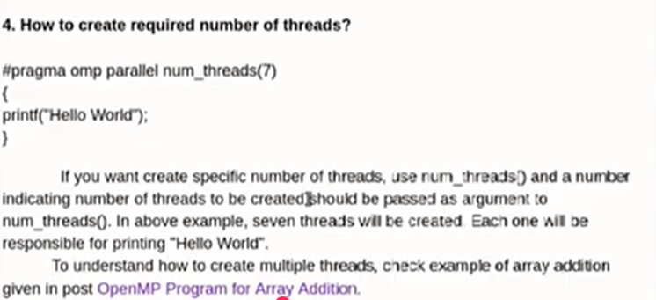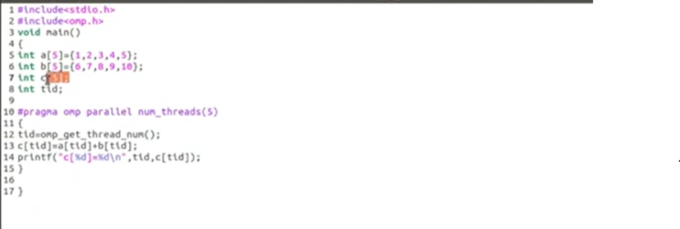

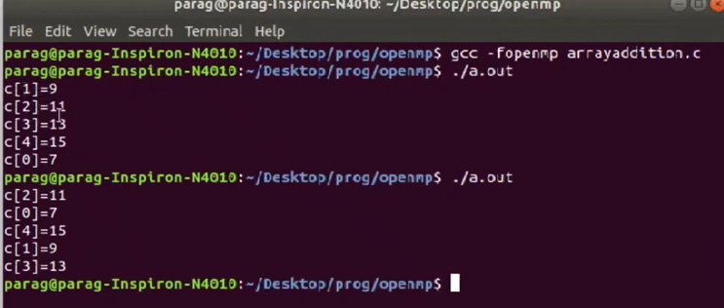

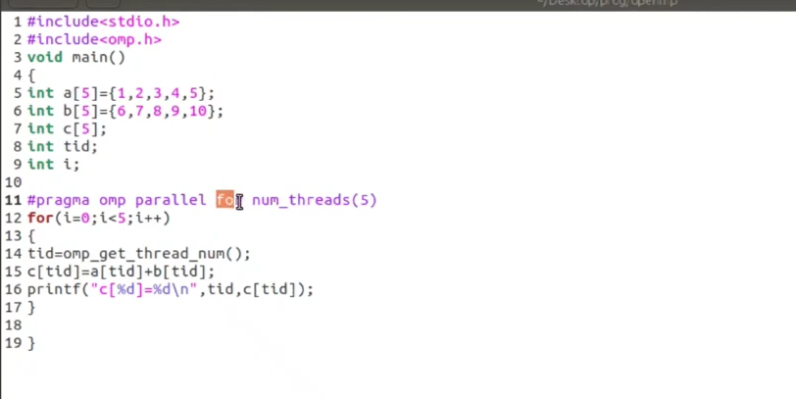

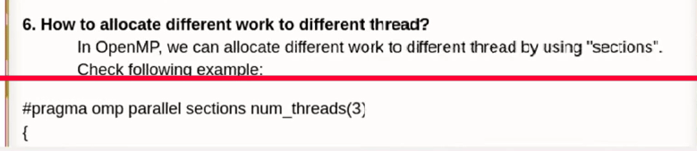

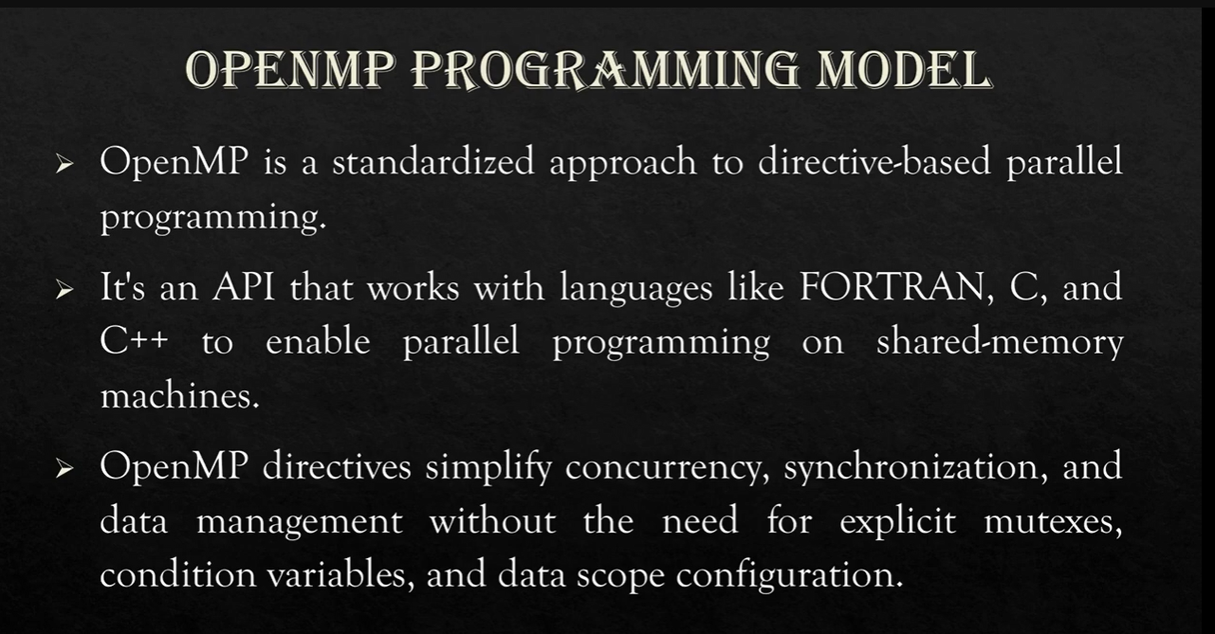

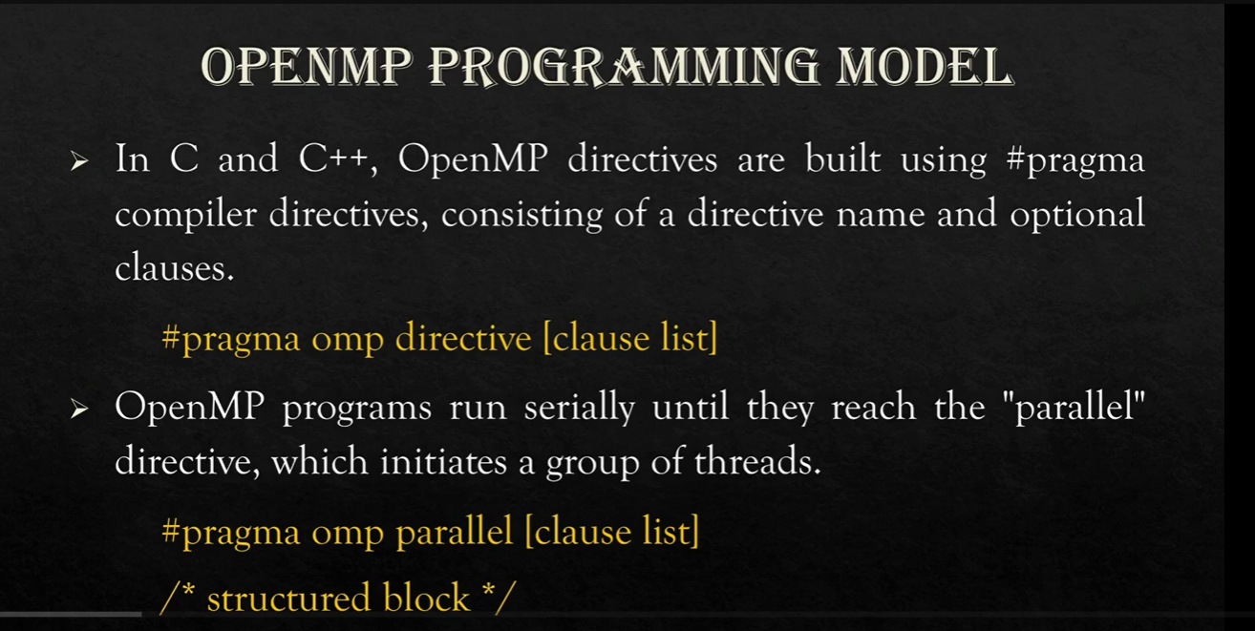

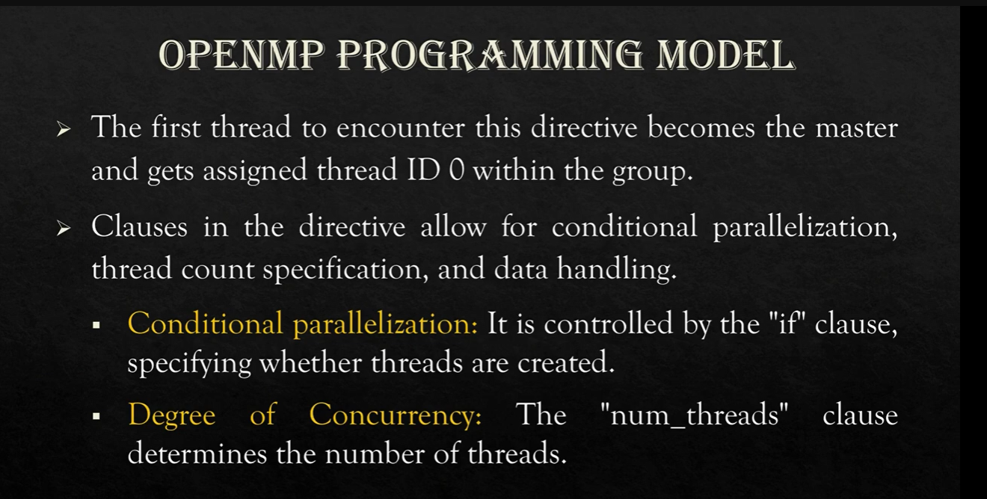

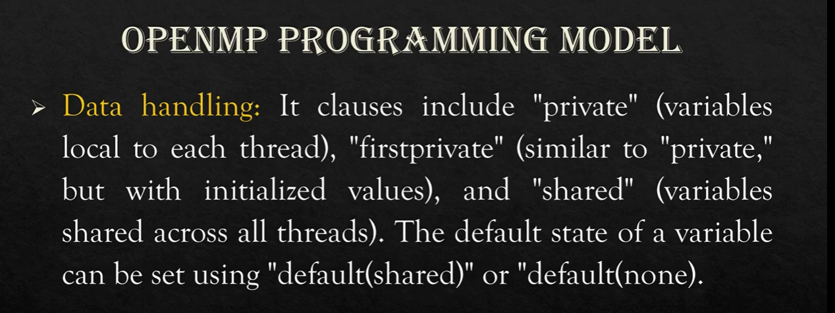

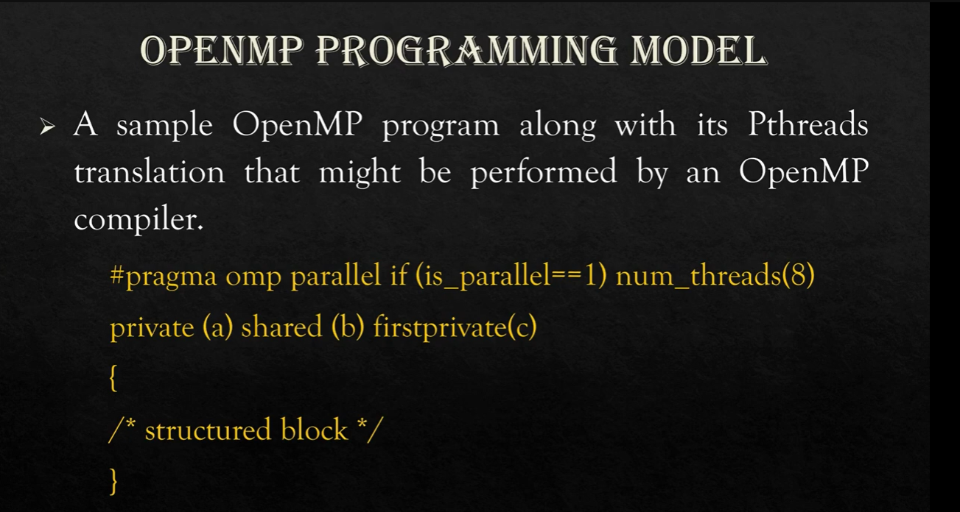

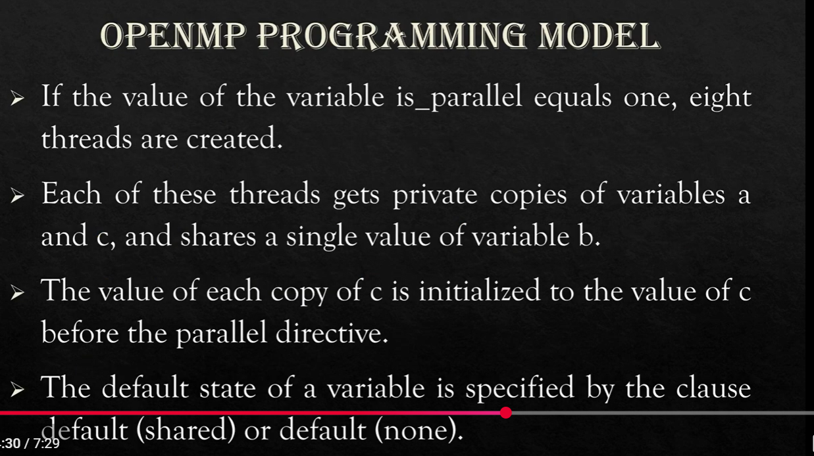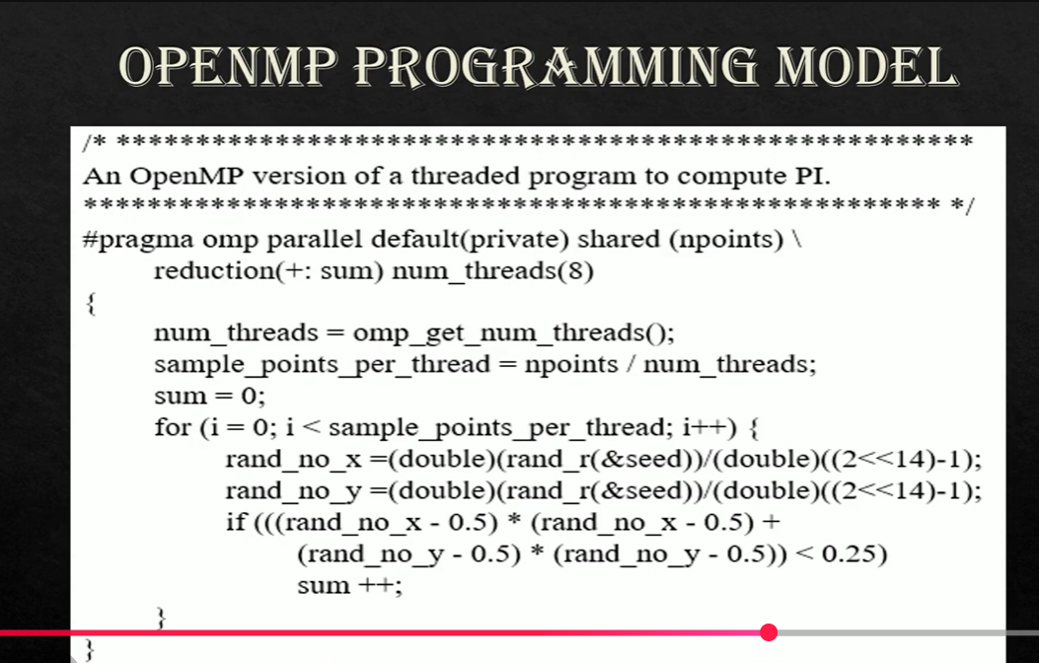

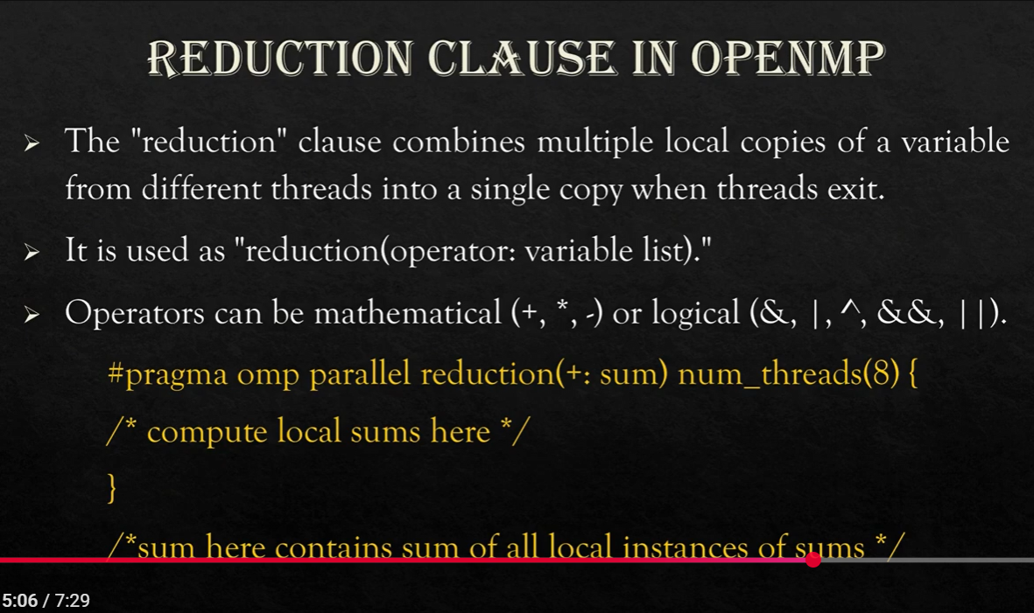

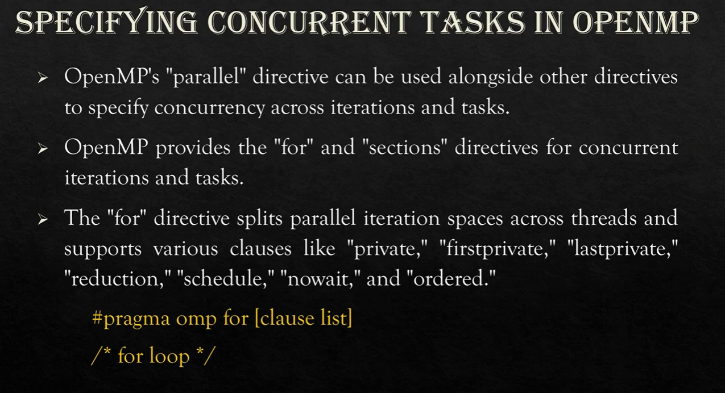

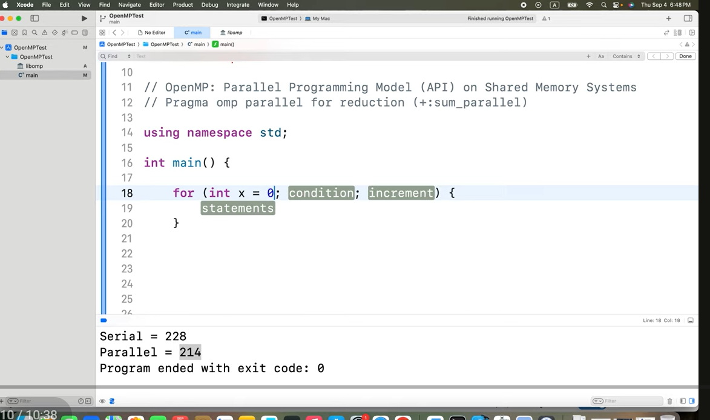

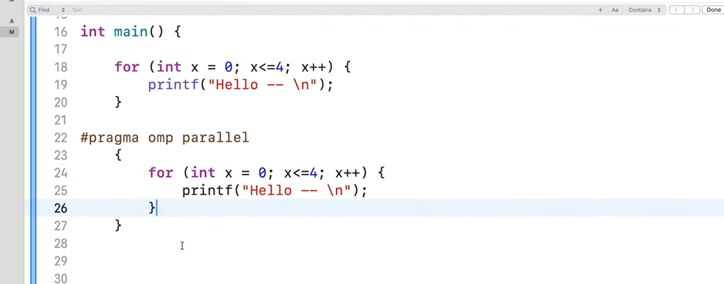

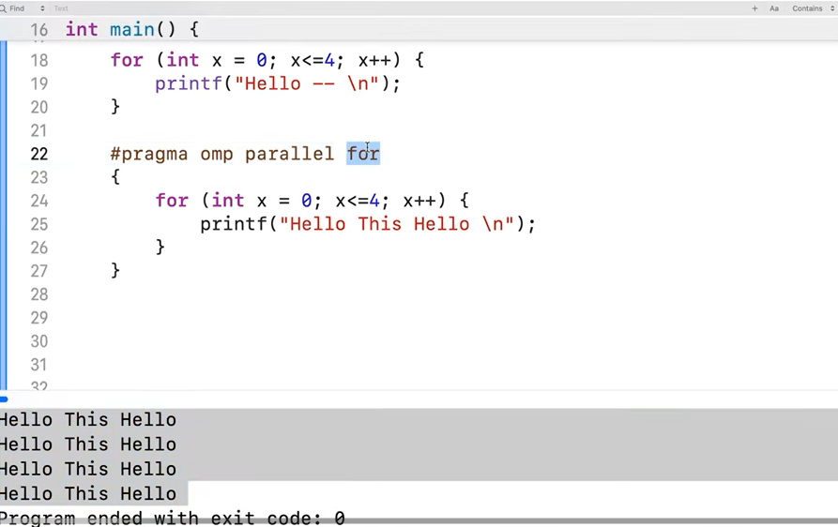

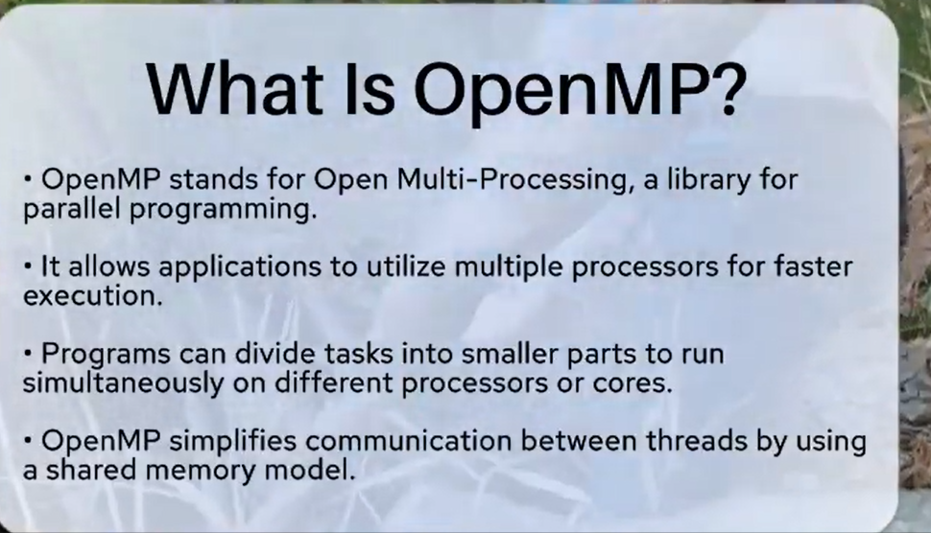

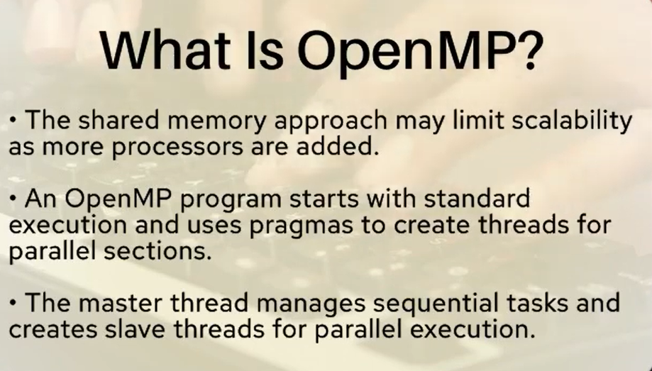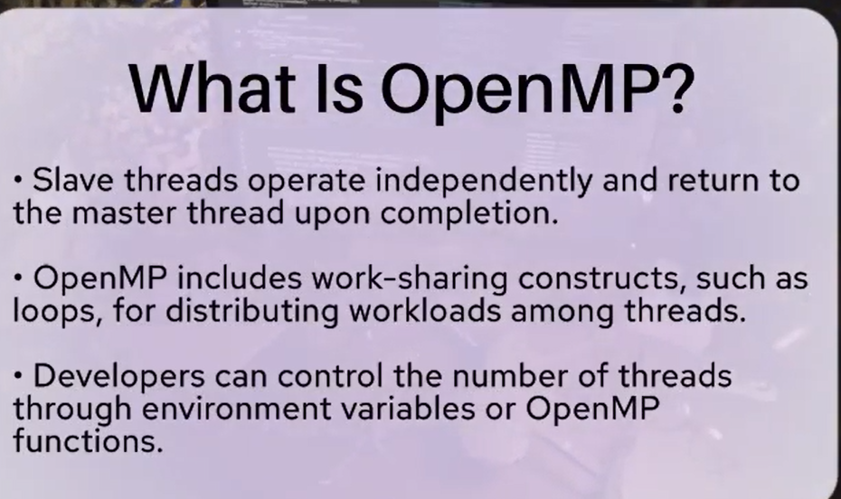

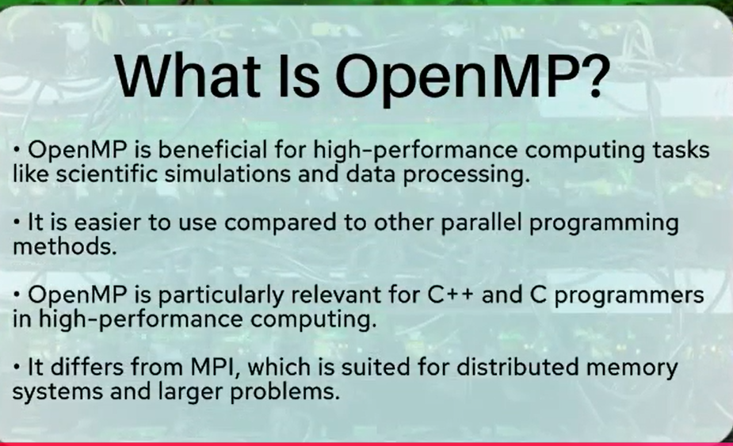

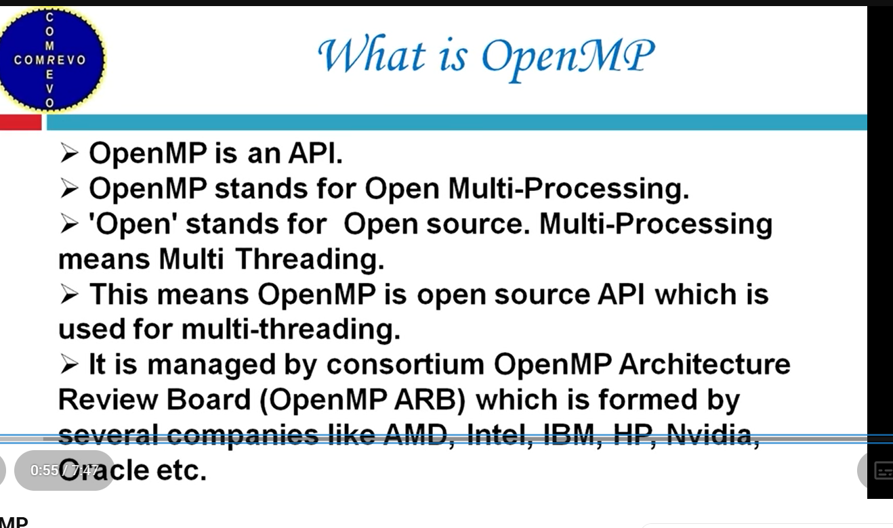

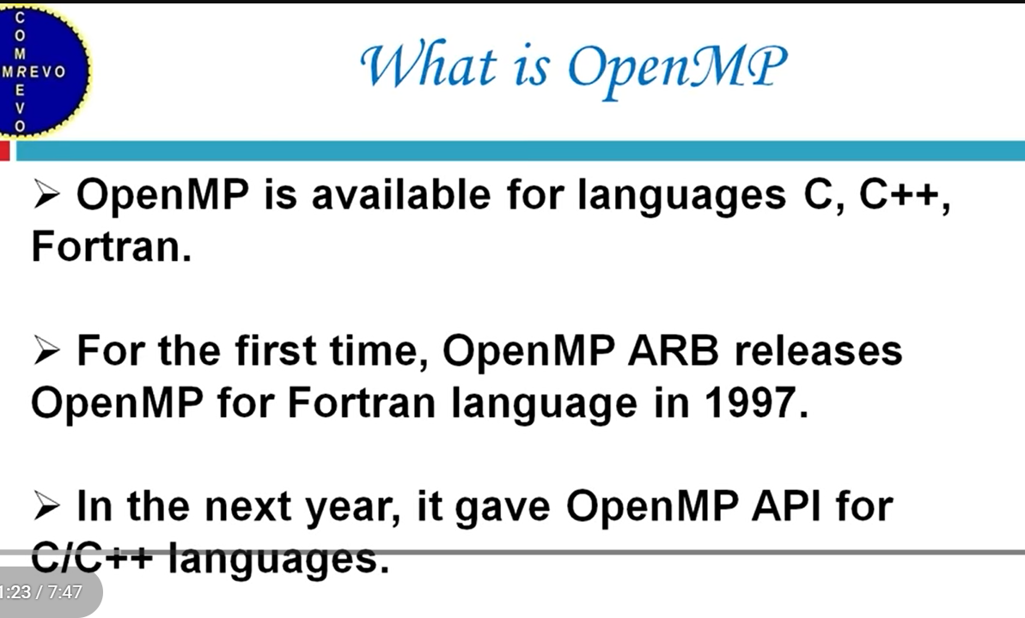

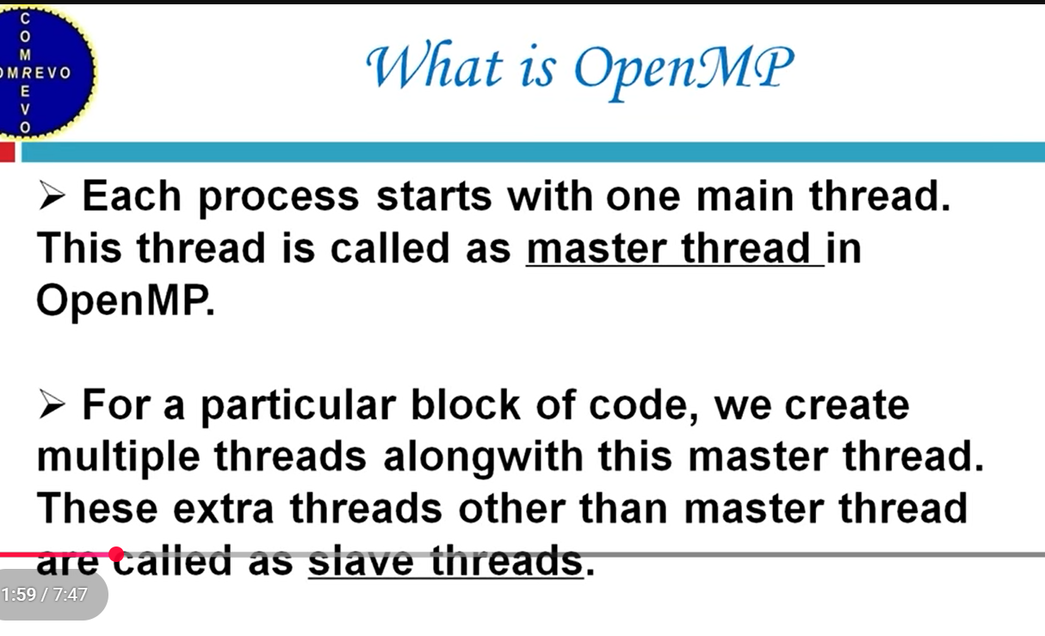

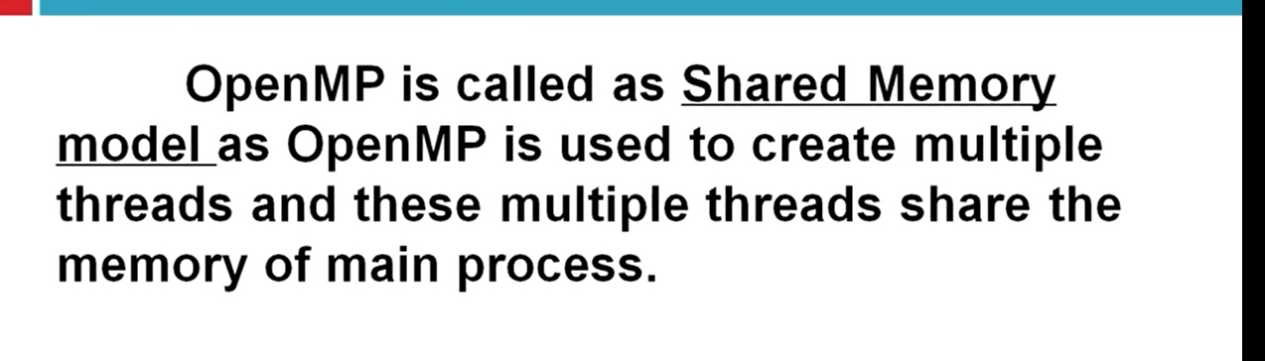

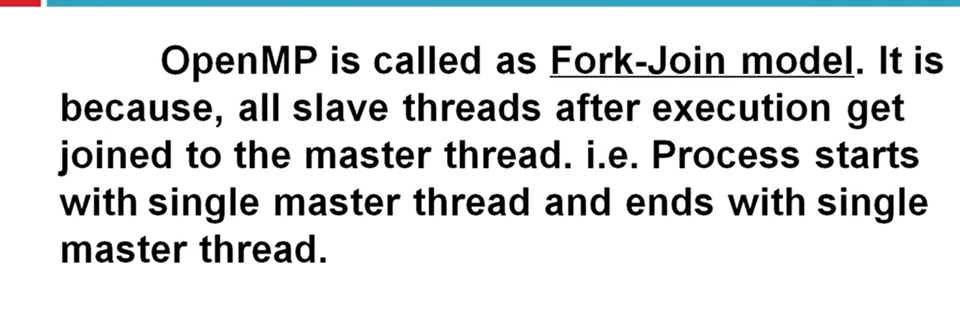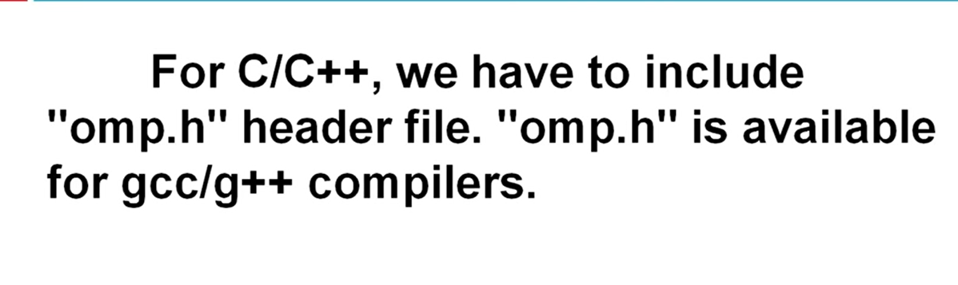

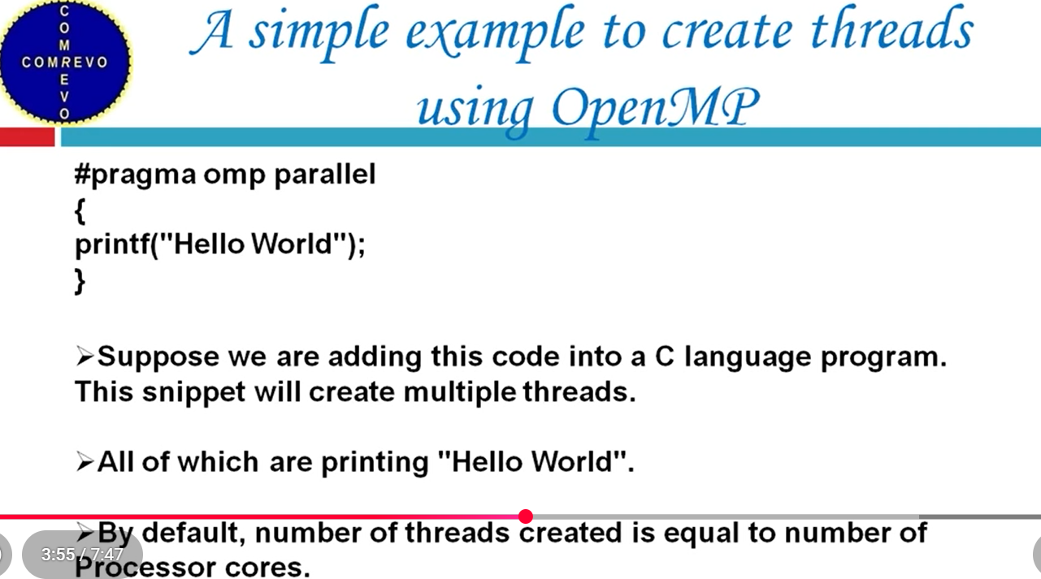

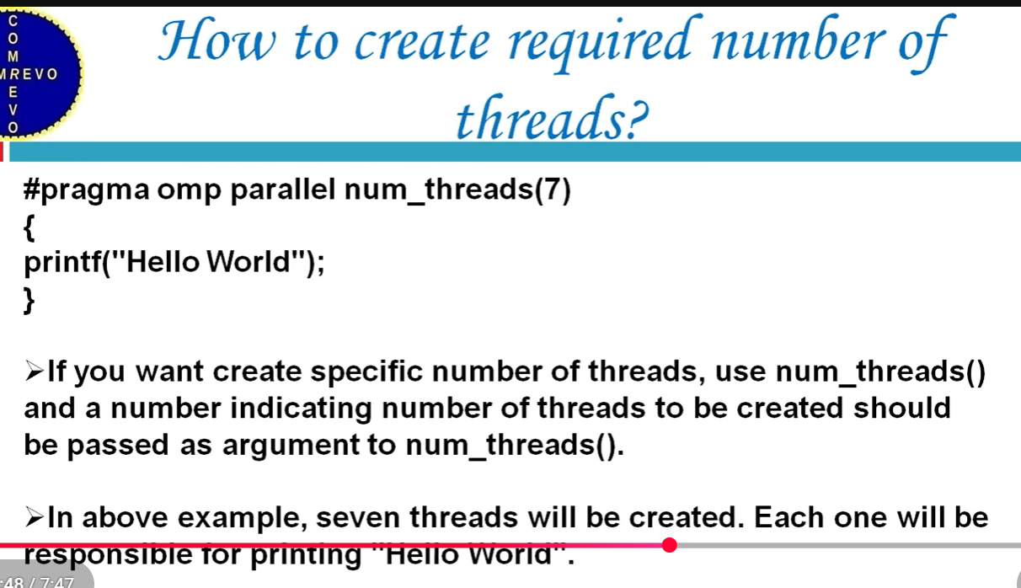

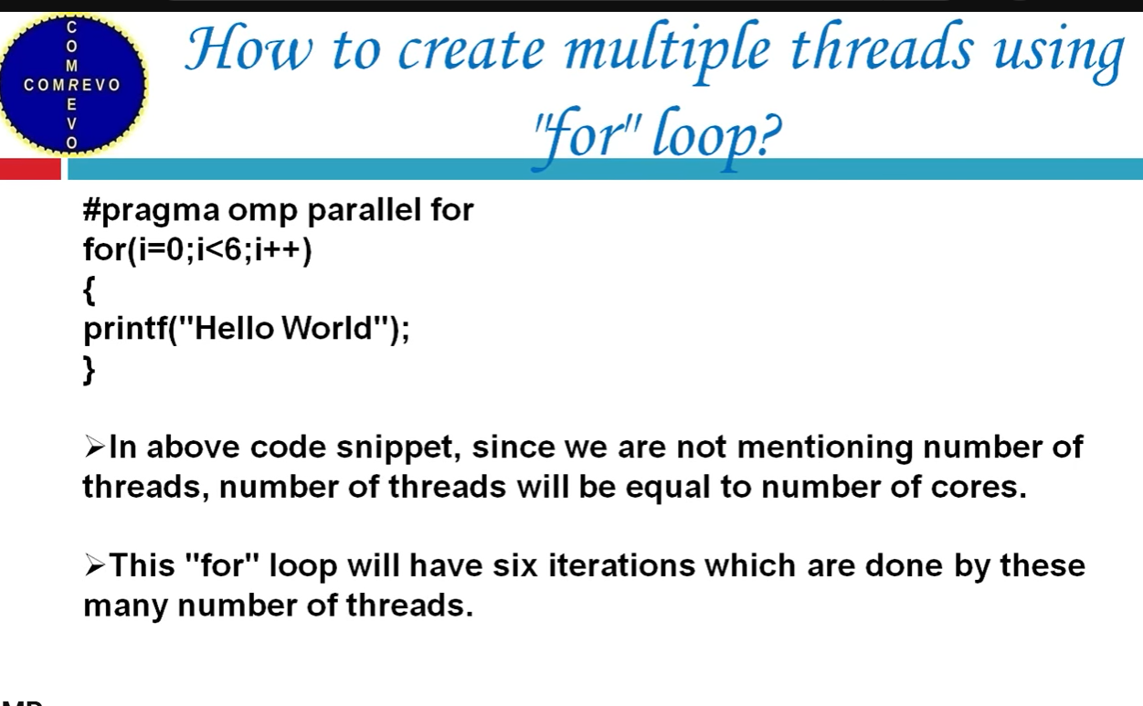

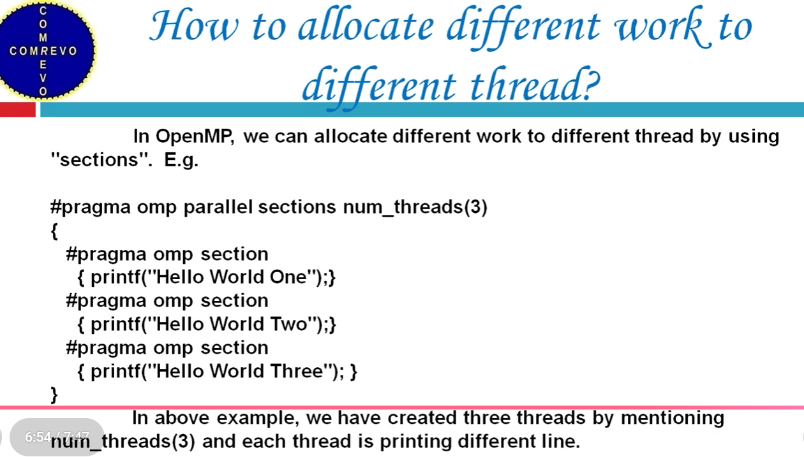

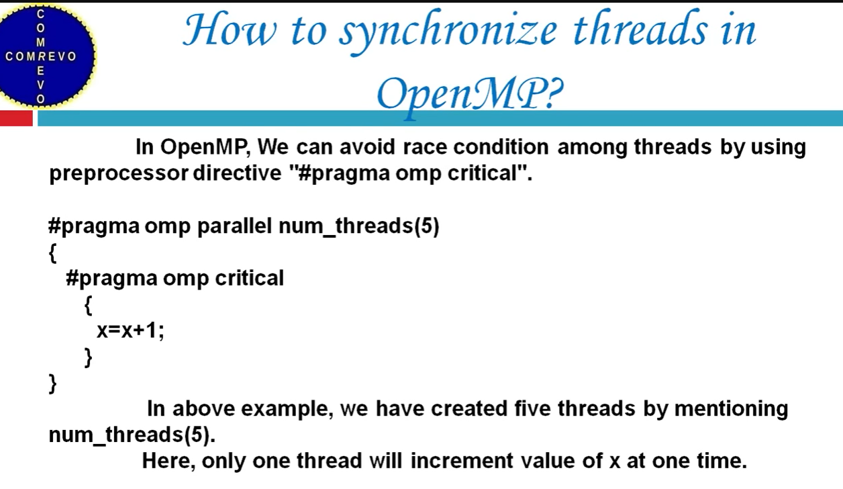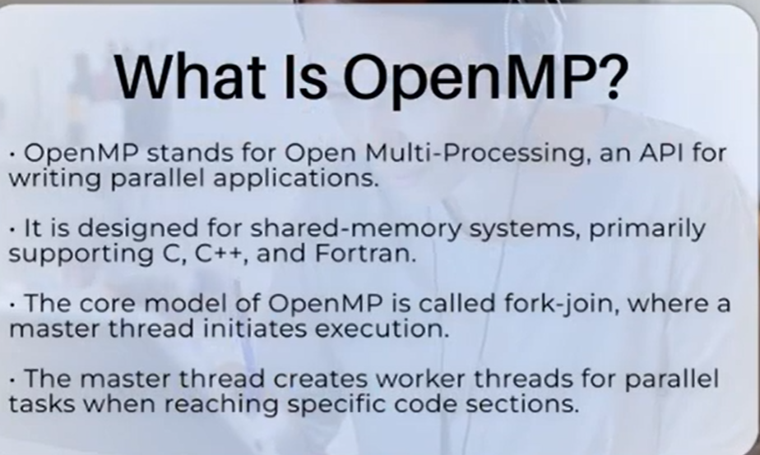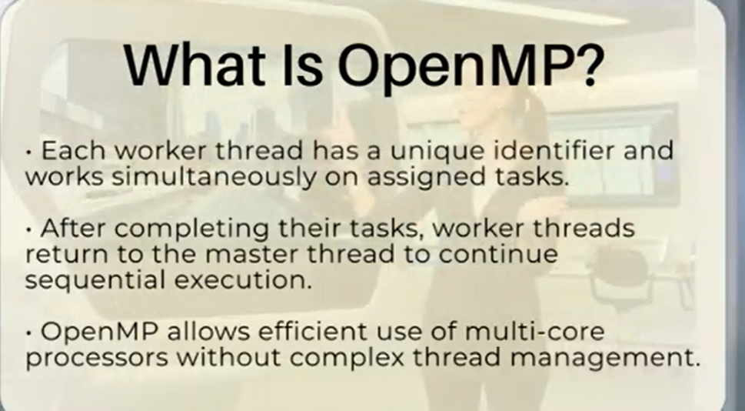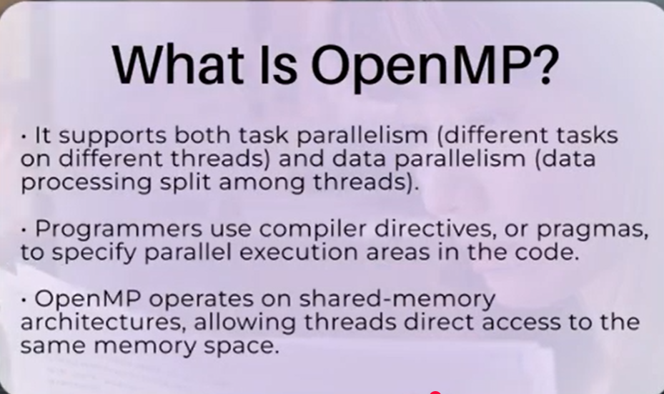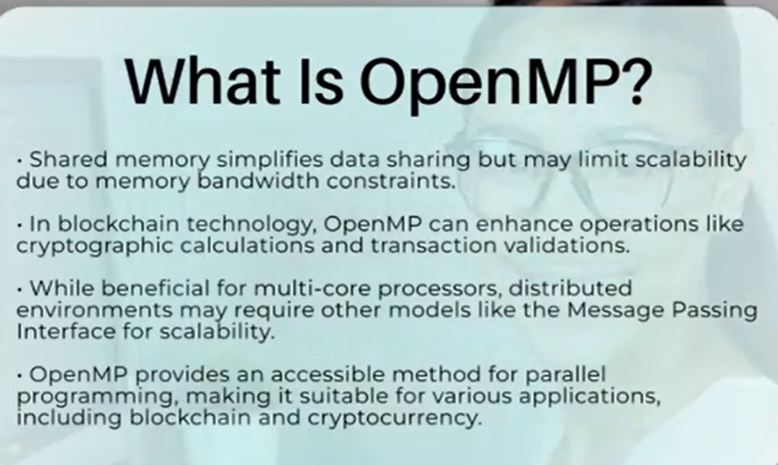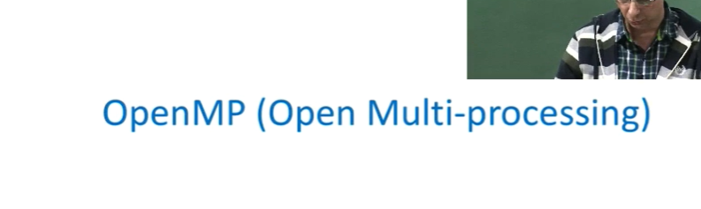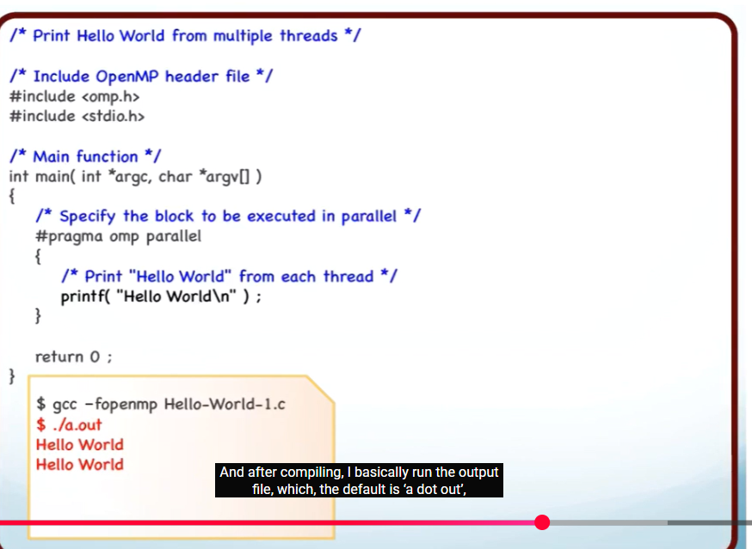

**1. What is Parallel & Distributed Computing?**

**Parallel Computing**

* Multiple **processors/cores** work **simultaneously**
* Share the **same memory**
* Faster execution of programs

Example:

* Modern CPUs (4-core, 8-core)
* Multithreading programs

**Distributed Computing**

* Multiple **separate computers (nodes)**
* Each has **its own memory**
* Communicate over a **network**

Example:

* Clusters
* Cloud systems

**2. What is OpenMP?**

**OpenMP (Open Multi-Processing)** is:

* An **API** for **parallel programming**
* Works on **shared memory systems**
* Used with **C, C++, and Fortran**

**Key idea:**

Convert **serial code → parallel code** using **compiler directives**

# 3. Why OpenMP?

Without OpenMP:

* Programmer manually manages threads
* Very complex and error-prone

With OpenMP:

* Simple #pragma directives
* Automatic thread management
* Portable & scalable

# 4. OpenMP Architecture

* **Fork–Join Model**

### How it works:

1. Program starts with **one thread (master)**
2. When a parallel region is encountered:
   * Master **forks** multiple threads
3. Threads execute in parallel
4. Threads **join** back to one

Serial → Parallel → Serial

5. Basic OpenMP Concepts

|  |  |
| --- | --- |
| **Concept** | **Meaning** |
| Thread | Small execution unit |
| Parallel Region | Code executed by multiple threads |
| Work Sharing | Divide work among threads |
| Synchronization | Control access to shared data |
| Data Scope | Shared or private variables |

# 17. Real-World Use Cases

* Image processing
* Matrix multiplication
* Scientific simulations
* Machine learning preprocessing
* Financial modeling

# 18. Complete Example: Vector Addition19. Advantages of OpenMP

✔ Easy to learn  
✔ Portable  
✔ Incremental parallelism  
✔ Scales with cores

**20. Limitations of OpenMP**

❌ Only shared memory  
❌ Limited for large clusters  
❌ Debugging can be hard

# 21. Exam-Ready Summary

* OpenMP is **shared-memory parallel programming API**
* Uses **compiler directives**
* Based on **fork-join model**
* Supports **parallel loops, sections, synchronization**
* Best for **multicore systems**

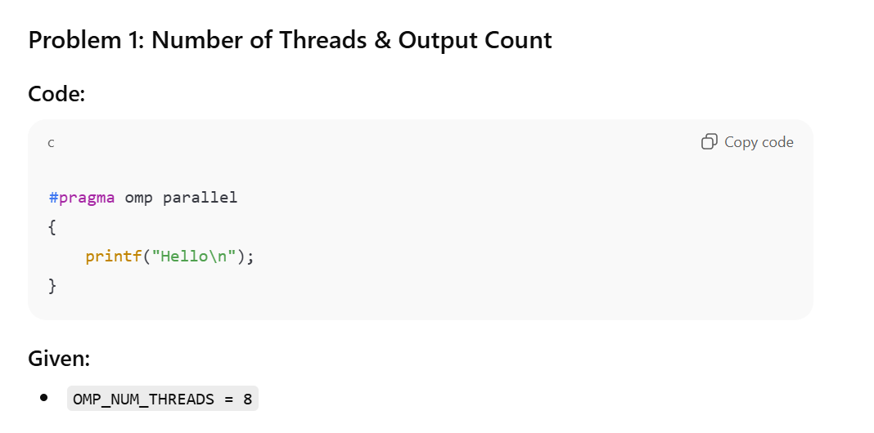

## 🔥 Exam Tip (Very Important)

Most common exam questions:

* Count outputs
* Identify race condition
* Apply **reduction**
* Calculate speedup & efficiency
* Thread ID ranges
* Scheduling behavior